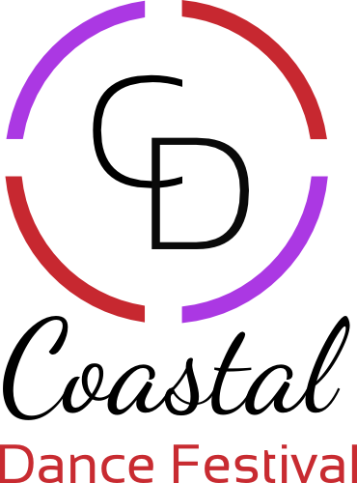

2021 Liability Waiver

Assumption of the Risk and Waiver of Liability Relating to Coronavirus/COVID-19
This waiver form must be signed and returned to Coastal Dance Festival organizers with an acknowledgement before any use of the facilities is made. Individuals who have travelled outside of Canada within the previous 14 days or who are sick or who have been in contact with someone who is suspected of having Covid-19 must not use the facilities or attend CDF events. This access may be withdrawn at any time based on health agency recommendations.

WAIVER OF LIABILITY I,
Full name of legal guardian of dancer(s)____________________________ would like my child/children to participate in the Coastal Dance Festival. In response to efforts to contain the spread of COVID-19 coronavirus, I am aware that I am using the facilities at my own risk and will ensure that I will conduct myself in a way that is appropriate. I confirm that I have not travelled outside of Canada for the past 14 days and have not been in contact with anyone who is suspected of having COVID-19. I do not have any symptoms of COVID-19 including but not limited to fever, sore throat, coughing, aches, respiratory problems, dry cough, fatigue, diarrhea, loss of taste or smell, chest pain, rash on skin, discolouration of fingers or toes, headache. The novel coronavirus, COVID-19, has been declared a worldwide pandemic by the World Health Organization. COVID-19 is extremely contagious and is believed to spread mainly from person-to-person contact. Coastal Dance Festival, its organizers (Julie Izad & Zoe Barbaro) have put in place preventative measures to reduce the risk of contracting COVID-19; however, Coastal Dance Festival cannot guarantee that you or your child(ren) will not become infected with COVID-19. Attending any public spaces increases your risk and your child(ren)’s risk of contracting COVID-19. By signing this agreement, I acknowledge the contagious nature of COVID-19 and voluntarily assume the risk that my child(ren) and I may be exposed to or infected by COVID-19 by attending the Coastal Dance Festival and that such exposure or infection may result in personal injury, illness, permanent disability, and death. I understand that the risk of becoming exposed to or infected by COVID-19 at Coastal Dance Festival may result from the actions, omissions, or negligence of myself and others, including, but not limited to, Coastal Dance Festival organizers, employees, volunteers, and program participants and their families.

I voluntarily agree to assume all of the foregoing risks and accept sole responsibility for any injury to my child(ren) or myself (including, but not limited to, personal injury, disability, and death), illness, damage, loss, claim, liability, or expense, of any kind, that I or my child(ren) may experience or incur in connection with my child(ren)’s attendance at Coastal Dance Festival or participation in programs at the Coastal Dance Festival Studios. On my behalf, and on behalf of my children, I hereby release, covenant not to sue, discharge, and hold harmless Coastal Dance Festival, its employees, agents, and representatives, of and from the Claims, including all liabilities, claims, actions, damages, costs or expenses of any kind arising out of or relating thereto. I understand and agree that this release includes any claims based on the actions, omissions, or negligence of Coastal Dance Festival, its employees, agents, and representatives, whether a COVID-19 infection occurs before, during, or after participation in any Coastal Dance Festival programs or events.

I grant Coastal Dance Festival permission to use photographs, videotapes, recordings or any other record of me as a participant or my child in the event for any legitimate purpose.
I consent to have medical treatment that may be deemed advisable in the event of injury, accident and/or illness during any program, event or activity. I release Coastal Dance Festival and all persons participating in any such medical treatment from all responsibility for any such actions.

Full Name of Dancer 1 (under 19yrs of age): __________________________________________

Full Name of Dancer 2 (under 19yrs of age): __________________________________________

Full Name of Dancer 3 (under 19yrs of age): __________________________________________

Today’s Date: Day __________.Month ___________ Year ______________

I have read, understand, and agree to the above terms of participation and the assumption of risk of participation and release all liability.

Full Name of Legal Guardian: ___________________ Signature: _________________________

